Sprint 2 Materials

907-30

Aaron Mathews

Adam Teo

Akshay Belhe

Chris Avila

Gabriel Floreslovo

[Margo Gongora](mailto:ngongora@tamu.edu)

# Retrospective Summary

When analyzing this sprint, we found that overall we did a grid job in organizing and executing our plan. We were able to complete every task that we assigned even though we upped our workload considerably in comparison to the last sprint. The only real roadblocks we had was the difficulty of implementation itself and the fact that we were all much busier with outside work this sprint. We did realize that we are missing some requirements for the final deliverable in our user stories, so we had to add chores to make up for these. Overall, we are happy with the progress.

# GitHub Release Link

<https://github.com/csce-315-331-2024a/project-3-full-stack-agile-web-project-3-907-30/releases/tag/2.0.0>

# Product Backlog

**Legend: E(n) = Estimated time (n) in hours, corresponds to n points; P(n) = Priority level n, determines dependency level; S(x) = Status x, 0 is incomplete, 1 is complete**

Dependencies: All items marked with priority 1 (P1) create the foundation for our project.

All items marked with priority 2 (P2) are tasks that create a more robust product, and are foundation adjacent, but do not act as building blocks for later tasks. They are most likely built on P1 tasks.

All items marked with priority 3 (P3) do not build any foundational elements of our app. They are all dependent on previous tasks. These tasks are to add finishing touches to the product.

**P1**

Stories 1, 6, & some tasks in 13 and 14: Login functionality

Story 5: Manager trend functionality (data retrieval and analysis)

Stories 7, 8, 9, 10, 11, & 12: Employee POS functionality

Story 18: Customer POS ordering functionality

Stories 19, 20, & 21: Accessibility features

**P2** - Needs all users to be logged in, Needs basic POS framework, Needs data retrieval/trends

Stories 2 & 3: Manager advanced trends and restaurant actions (Needs login, Needs data retrieval/trends)

Story 10: Extra item information for employee at POS (Needs basic POS framework)

Stories 15, 16, & some tasks in 14: Customer account information and interaction (Needs login, data retrieval/trends, basic POS framework)

**P3**  - Needs login, POS framework, and data retrieval/trends

Stories 17, & dome tasks in 13 and 14: Customer and employee statistics and account information (Needs login, data retrieval/trends, basic POS framework)

Chores are broken down very similarly; but because they were all added after basic functionality was finished, they are not dependent on unfinished features

Manager stories:

* 1. As a manager I want to be able to securely login to my Manager view so that I can make managerial adjustments without allowing any other people to view the sensitive information that I have access to.
  + 1. Make Manager GUI login view that prompts a username and password and uses google oauth to make a secure login E3 P1 S1
  + 1. Modify schema to hold google Oauth necessary information E2 P1 S1
  + 1. Implement login and logout routes and corresponding hooks E1 P1 S1
* 2. As a manager, I want to be able to view past orders and see what is selling the least, so we can advertise it more.
  + 2. Make function that queries the menu items that have sold the least and the amounts that they have sold in ascending order (least sales first); have 10 item cutoff (bottom 10 sellers) E1 P2 S1 - **Aaron**
  + 2. Add functionality to the function that queries the menu items that contribute the smallest percentage to the total revenue as well, for a more accurate view of the weak links E1 P2 S1
  + 2. Make GUI panel/page that shows these items in order with their categories E2 P2 S1
  + 2. Have GUI make the items that pop up interactable; eg if you click corn dogs because they’re selling poorly, it should take you to the menu items view where you can edit the corndog item or add a promotion to it E3 P2 S1
* 3. As a manager, I want to make any item on sale to increase orders.
  + 3. Make GUI edit menu item view have an option to put the item on sale E1 P2 S0
  + 3. Have a function that updates menu item’s prices when they go on sale E1 P2 S0
  + 3. Make GUI menu item sale view have a date range option using a calendar date selection to determine how long the sale will last E1 P2 S0
  + 3. Make menu item return to default price when sale window passes E2 P2 S0
* 4. As a manager, I want to be able to see what employees have made the most orders so I can see which employee is most valuable. 2
  + 4. Make Manager GUI page that shows employee performance E2 P1 S1
  + 4. Make function that queries the employees with the most total orders made E1 P1 S1
* 5. As a manager I want to be able to see trends in sales data so I can estimate inventory purchasing and present to business owners. * 5 (queries all done tho) **, Gabe, Margo, Aaron**
  + 5. Make Manager GUI page that has a menu of available trend reports E3 P1 S1
  + Make functions for the following trend reports:
    - 5. What sells together E2 P1 S1
    - 5. Product Usage Chart E2 P1 S1
    - 5. Sales Report E2 P1 S1
    - 5. Excess Report E2 P1 S1
    - 5. Restock Report E2 P1 S1
    - 5. Days with the most sales in a given month E2 P1 S1
* 6. As a manager, I want to be able to give new employees the ability to make orders but not access the manager view * 3
  + 6. Managers can view all employee accounts that have logged into the POS system E2 P1 S1
  + 6. Managers can make accounts "employees" through a button click in the manager view E1 P1 S1
  + 6. Restrict access of manager page from employees E1 P1 S1

Employee stories:

* 7. As an employee, I want to be able to make orders so I can translate a customer’s desires to the kitchen.
  + 7. Make Employee GUI POS system that allows employees to create, delete, customize, and see the information contained within an order E1 P1 S1
  + 7. Make functions that can create, delete, view, and modify the orders in the database E1 P1 S1
  + 7. Make function that queries all of a menu item’s relevant information E2 P1 S1
  + 7. Have GUI call and display the results of that function when a customer is selecting a given item E1 P1 S1
* 8. As an employee, I want to be able to clear an order so that I can respond to a customer changing their mind.
  + 8. Make POS system have a clear order button that removes all of the items in the order list E1 P1 S1
* 9. As an employee, I want to receive instant notifications on insufficient stock levels before placing orders.
  + 9. Make a function that quickly queries the stock information of the inventory items that make up a menu item and alerts if there is low / no stock E1 P1 S1
  + 9. Have GUI call this function when an employee selects a menu item for an order E1 P1 S1
* 10. As an employee, I want to be able to view product information so I can inform the customer without leaving.
  + 10. Make a function that queries all of the relevant characteristics of a menu item like allergen information. E1 P2 S1
  + 10. Have GUI show this information to the employee when they click on a menu item at POS. E1 P2 S1
* 11. As an employee, I want to be able to quickly add extra quantities for one item so I can respond to customer wants.
  + 11. Have GUI at POS give the option of selecting the number of items that will be added to an order when creating it E1 P1 S1
* 12. As an employee, I want to be able to see the order total so I can read it out and double check with the customer.
  + 12. Have GUI at POS show the subtotal, tax, and final total for an order when as the order is being built E1 P1 S1
* 13. As an employee, I want to be able to see what items I have sold the least to tailor my sales strategy around it.
  + 13. Make Employee GUI view that shows employee information E1 P3 S0
  + 13. Make function that queries the information stored for a given, logged-in employee E1 P3 S0
  + 13. Make Employee GUI login view using google OAuth E2 P1 S1
  + 13. Implement login and logout routes and corresponding hooks E3 P1 S1
  + 13. Store session information in cookies when logged in E1 P1 S1
  + 13. Save current user’s information during their session to be used in their tasks (making an order should assign the currently logged in employee to the order) E1 P1 S1

Customer stories:

* 14. As a customer, I want to be able to log in to see my past orders and points so that I can re-order or just see what I like.
  + 14. Make Customer GUI “login” view that asks for relevant information (email) E2 P1 S1
  + 14. Implement Google OAuth API functionality for customers to login E3 P1 S1
  + 14. Implement login and logout routes and corresponding hooks E1 P1 S1
  + 14. Make Customer GUI information view that shows all of the relevant information (general and rewards) on a customer’s account E2 P3 S1
  + 14. Create new tables and/or columns in the database holding the extra rewards information E2 P3 S1
  + 14. Make function that queries a customer’s general information E1 P2 S1
  + 14. Make function that queries a customer’s purchase history E1 P2 S1
  + 14. Make a function that queries a customer’s rewards information E1 P3 S1
* 15. As a customer, I want to see items that are on promotion so that I could make an informed purchasing decision.
  + 15. Make the Customer POS view highlight the items that are on sale in some way **E1 P2 S0**
  + 15. Make function that queries all of the items that are on sale **E1 P2 S0**
* 16. As a customer I want to see allergy and dietary information so I can make an informed decision about what to eat. 1
  + 16. Have GUI show allergy alerts when the customer selects an item E2 P2 S1
  + 16. Make function that retrieves the allergy information for a menu item E1 P2 S1
* 17. As a customer, I want to gain points for previous transactions, so I can use that information to get discounted items. 3
  + 17. Have GUI give feedback to logged-in customers showing how many points they have earned for an order E1 P3 S1
  + 17. Have Customer GUI view that shows the rewards they can get with their point balance E2 P3 S1
  + 17. Create new tables and columns in the database to hold the information on rewards and deals E1 P3 S1
  + 17. Make function to query what rewards are available with the point total of the given customer E1 P3 S1
* 18. As a customer, I want to be able to see menu items and their respective prices clearly, so I can use that information to make my order.
  + 18. Make sure GUI has obvious design that clearly shows what an item looks like, and shows the item’s information obviously when selected E2 P1 S1

Accessibility stories:

* 19. As a user who is blind, I want to be able to use the website with the help of a screen reader, so that I know what is being displayed. 2
  + 19. Add screen reader functionality to all GUI items in sprint 1 E1 P1 S1
  + 19. Add screen reader functionality to all GUI items in sprint 2 E1 P1 S1
  + 19. Add screen reader functionality to all GUI items in sprint 3 E1 P1 S0
* 20. As a user who has poor vision, I want to be able to see and use the website without any additional help, so I can order correctly. 2
  + 20. Make sure that all views have high color contrast and easily legible font in sprint 1 E1 P1 S1
  + 20. Make sure that all views have high color contrast and easily legible font in sprint 2 E1 P1 S1
  + 20. Make sure that all views have high color contrast and easily legible font in sprint 3 E1 P1 S0
* 21. As a non-english speaking user, I want to be able to read the site in my native language so that I can order what I want without a substantial barrier. 2
  + 21. Add google translate functionality to all GUI items in sprint 1 E2 P1 S1
  + 21. Add google translate functionality to all GUI items in sprint 2 E2 P1 S1
  + 21. Add google translate functionality to all GUI items in sprint 3 E1 P1 S0

Chores:

* As a customer, I’d like to be able to see the weather E4 P2 S1 - Margo
* Start reconfiguring database for sale items E1 P2 S1 - Gabe
* Configure database for customer points/rewards E3 P2 S1 - Gabe
* Clean up the UI for ordering - Adam
  + Add tabs to customer and employee ordering E3 P2 S1 - Adam
  + Make menu board on theme E1 P2 S1 - Adam
* Allow managers to input date ranges for trends - Margo E2 P1 S0
* Try to make interactable way to update menu items - Aaron E2 P2 S0
* Add front-end for customers to see their past orders - Margo E1 P1 S0
* Move all trend functionality to api’s - Margo E1 P3 S0
* Clean up Allergen UI for customer view with Halal and Vegan - Chris E1 P2 S0
* Clean up logic for excess report form - Aaron E1 P2 S0
* Add bounds checking to manager trend inputs - Chris E1 P2 S0
* Clean up menu management card - Aaron E1 P2 S0
* Fix duplicate customers being added - Gabe E1 P1 S0
* Fix menu item makeup - Gabe E2 P2 S0
* Remove Google Translate loading circle - Adam E1 P3 S0
* Allows employees to remove items from order in receipt - Akshay E1 P1 S0
  + Allow customers to make orders in the customer view page - Akshay
  + Customers can create orders - Akshay E2 P1 S0
  + Customers can remove items from orders - Akshay E1 P1 S0
  + …
* Allow modifications in all ordering views - Akshay E3 P1 S0
* Recommend items based on weather - Margo E2 P2 S0
* Order management - Adam, Akshay
  + View all orders; view a single order (including status: pending, fulfilled, canceled, etc.) - Adam E2 P1 S0
  + Modify an order (add/remove items, change status, etc.) - Adam E3 P1 S0
  + Remove an order from the order history - Akshay E1 P1 S0
* Inventory management - Adam
  + Add a new item to the inventory - Adam E2 P1 S0
  + View all inventory items; view a single inventory item - Adam E1 P1 S0
  + Modify an item in the inventory (name, quantity, supplier, etc.) - Adam E1 P1 S0
  + Remove an item from the inventory - Adam E1 P1 S0
* Menu management - Aaron E3 P1 S0
  + Add a menu item - Aaron E1 P1 S0
  + View current menu items - Aaron E1 P1 S0
  + Modify a menu item (name, price, ingredients, description, status, etc.) - Aaron E2 P1 S0
  + Remove an item from the menu - Aaron E1 P1 S0
  + Add/update/remove seasonal menu items, "seasonal" := defined availability window, visible on all applicable views - Chris E3 P2 S0
* Mobile friendly for customer view - Adam E3 P1 S0
* Fix WAVE accessibility issues - Gabe E3 P1 S0
* Fix accessibility checker issues - Gabe E3 P1 S0
* Add more tests with playwright - Margo E3 P1 S0
* Measure code coverage with playwright - Margo E1 P1 S0
* Remove user in user management - Adam E1 P1 S0
* Add pictures to static menu board - Adam E2 P2 S0
* Link to external site - Akshay E1 P3 S0
* One more API functionality - Akshay E3 P3 S0
* Host documentation - Chris E3 P1 S0
* Add deprecated column when removing menu items to prevent side effects - Gabe E2 P2 S0

Sprint Backlog

**Legend: #. = Corresponding story, En = N hours estimated to complete, Sy = y status (0 not complete, 1 complete), Tn = N hours spent on the task**Ex:

* Story
  + task
    - sub-task
* 2. As a manager, I want to be able to view past orders and see what is selling the least, so we can advertise it more. - Aaron
  + 2. Make function that queries the menu items that have sold the least and the amounts that they have sold in ascending order (least sales first); have 10 item cutoff (bottom 10 sellers) E1 P2 T2 - Aaron
  + 2. Add functionality to the function that queries the menu items that contribute the smallest percentage to the total revenue as well, for a more accurate view of the weak links E1 P2 T2 - Aaron
  + 2. Have GUI make the items that pop up interactable; eg if you click corn dogs because they’re selling poorly, it should take you to the menu items view where you can edit the corndog item or add a promotion to it E3 P2 T3 - Aaron
* 4. As a manager, I want to be able to see what employees have made the most orders so I can see which employee is most valuable. - Adam
  + 4. Make Manager GUI page that shows employee performance E2 P1 T1 - Adam
  + 4. Make function that queries the employees with the most total orders made E1 P1 T1 - Adam
* 5. As a manager I want to be able to see trends in sales data so I can estimate inventory purchasing and present to business owners. - Adam, Gabe, Margo, Aaron
  + 5. Make Manager GUI page that has a menu of available trend reports E3 P1 T2 - Adam
  + 5. Make functions for the following trend reports:
    - 5. What sells together E2 P1 T2 - Gabe
    - 5. Product Usage Chart E2 P1 T1 - Margo
    - 5. Sales Report E2 P1 T2 - Margo
    - 5. Excess Report E2 P1 T2 - Aaron
    - 5. Restock Report E2 P1 T2 - Aaron
    - 5. Days with the most sales in a given month E2 P1 T1 - Gabe
* 7. As an employee, I want to be able to make orders so I can translate a customer’s desires to the kitchen. - Akshay
  + 7. Make Employee GUI POS system that allows employees to create, delete, customize, and see the information contained within an order E1 P1 T1 - Akshay
  + 7. Make functions that can create, delete, view, and modify the orders in the database E1 P1 T2 - Akshay
  + 7. Have GUI call and display the results of that function when a customer is selecting a given item E1 P1 T1 - Akshay
* 10. As an employee, I want to be able to view product information so I can inform the customer without leaving. - Margo
  + 10. Make a function that queries all of the relevant characteristics of a menu item like allergen information. E1 P2 T1 - Margo
  + 10. Have GUI show this information to the employee when they click on a menu item at POS. E1 P2 T2 - Margo
* 14. As a customer, I want to be able to log in to see my past orders and points so that I can re-order or just see what I like. - Gabe
  + 14. Make Customer GUI “login” view that asks for relevant information (phone number) E2 P1 T1 - Gabe
  + 14. Implement encrypted database login functionality for customers to login E3 P1 T4 - Gabe
  + 14. Implement login and logout routes and corresponding hooks E1 P1 Tx - Gabe (deprecated)
  + 14. Make Customer GUI information view that shows all of the relevant information (general and rewards) on a customer’s account E2 P3 S1 - Gabe
  + 14. Create new tables and/or columns in the database holding the extra rewards information E2 P3 T1 - Gabe
  + 14. Make function that queries a customer’s general information E1 P2 T2 - Gabe
  + 14. Make function that queries a customer’s purchase history E1 P2 T2 - Gabe
  + 14. Make a function that queries a customer’s rewards information E1 P3 T1 - Gabe
* 16. As a customer, I want to see allergy and dietary information so I can make an informed decision about what to eat. - Chris
  + 16. Have GUI show allergy alerts when the customer selects an item E2 P2 T2 - Chris
  + 16. Make function that retrieves the allergy information for a menu item E1 P2 T1 - Chris
* 17. As a customer, I want to gain points for previous transactions, so I can use that information to get discounted items. - Akshay
  + 17. Have GUI give feedback to logged-in customers showing how many points they have earned for an order E1 P3 T2 - Akshay
  + 17. Have Customer GUI view that shows the rewards they can get with their point balance E2 P3 T1 - Akshay
  + 17. Make function to query what rewards are available with the point total of the given customer E1 P3 T1 - Akshay
* 19. As a user who is blind, I want to be able to use the website with the help of a screen reader, so that I know what is being displayed.
  + 19. Add screen reader functionality to all GUI items in sprint 2 E1 P1 T1 - Gabe
* 20. As a user who has poor vision, I want to be able to see and use the website without any additional help, so I can order correctly.
  + 20. Make sure that all views have high color contrast and easily legible font in sprint 2 E1 P1 T1 - Gabe
* 21. As a non-english speaking user, I want to be able to read the site in my native language so that I can order what I want without a substantial barrier. - Chris
  + 21. Add google translate functionality to all GUI items in sprint 2 E2 P1 T3 - Chris

### **Chores (part of the backlog, but have no story points associated with them)**

* As a customer, I’d like to be able to see the weather E4 P2 T2 - Margo
* Start reconfiguring database for sale items E1 P2 T1 - Gabe
* Configure database for customer points/rewards E3 P2 T4 - Gabe
* Clean up the UI for ordering - Adam
  + Add tabs to customer and employee ordering E3 P2 T2 - Adam
  + Make menu board on theme E1 P2 T2 - Adam

| Member | Sprint 1 Points | Sprint 2 Points | Sprint 2 Chores | Sprint 3 Points | Sprint 3 Chores |  |
| --- | --- | --- | --- | --- | --- | --- |
| Aaron Mathews | 4 | 9 |  |  |  |  |
| Adam Teo | 7 | 6 | 2 |  |  |  |
| Akshay Belhe | 8 | 7 |  |  |  |  |
| Chris Avila | 4 | 5 |  |  |  |  |
| Gabriel Floreslovo | 3 | 16 | 2 |  |  | SCRUM MASTER |
| Margo Gongora | 5 | 6 | 1 |  |  |  |

*It is important to mention that many of (my) Gabriel’s points were partially done in the previous sprint due to accidental overlap and one task was deprecated. The workload was split evenly between all members (I) Gabriel was able to maintain scrum master duties without issue.

# Burn-down Charts

Product Burndown:

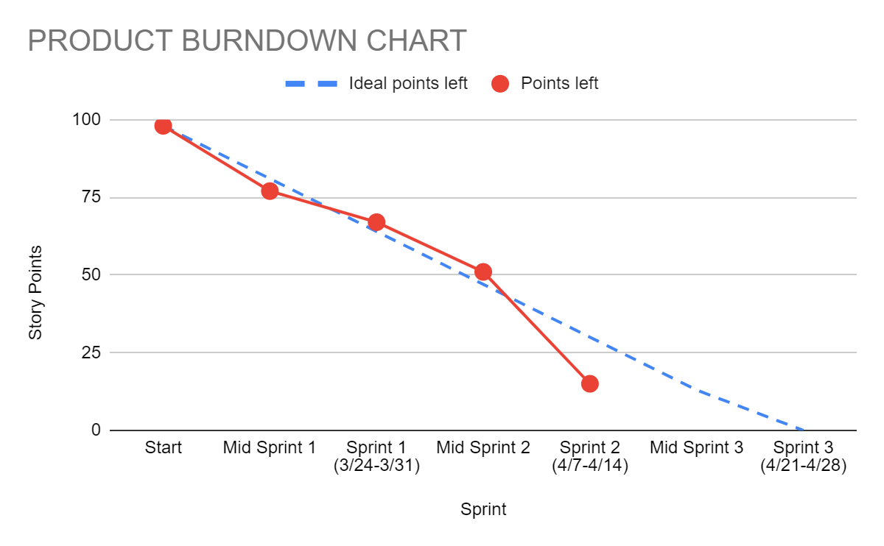

Sprint 2 Burndown:

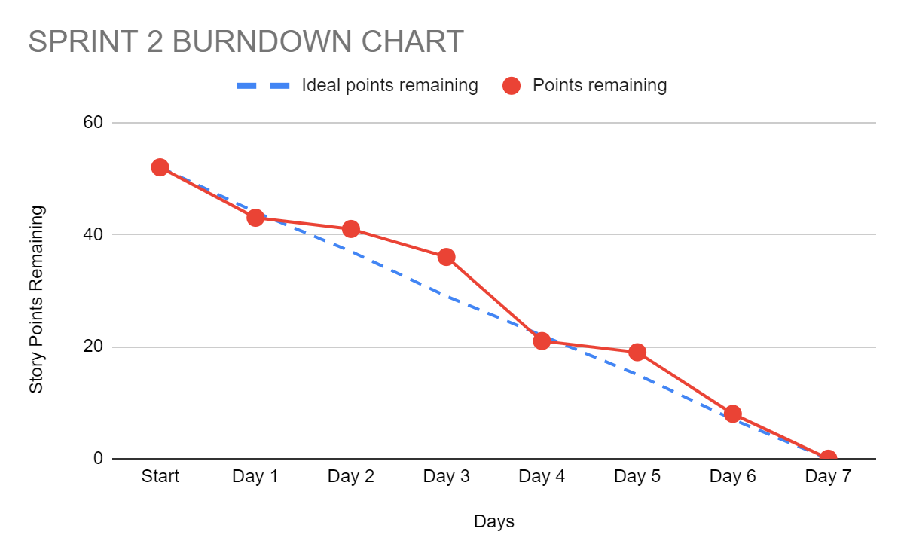

# Next Sprint’s SCRUM Meeting Schedule

Meeting 1 - Monday 4/22/24 15 minutes before lab

Meeting 2 - Tuesday 4/23/24 15 minutes before lab

Meeting 3 - Wednesday 4/24/24 15 minutes before lab

Meeting 4 - Thursday 4/25/24 15 minutes before lab

Appendix 1: SCRUM Meeting Agendas and Minutes

### **Sprint 2 Stand-up 1 for CSCE 331 Project 3**

### **Prepared by: Gabriel Floreslovo**

### **Meeting Date: 4/8/2024**

## **Meeting Attendees**

* Adam Teo
* Akshay Belhe
* Aaron Mathews
* Chris Avila
* Margo Gongora
* Gabriel Floreslovo

## **Agenda**

* What we have finished, what we have left, and how we will do it
* Conduct "fist of five" vote on the confidence in acheiving the sprint goal
* Share any roadblocks that are interrupting progress

## **What we have completed**

* Fixed employee ordering bugs - Akshay
* Finished employee ordering story - Akshay
* All chores finished - Adam
* Re-wrote playwright tests to match new design changes - Adam
* Wrote allergy API, made weather badge - Margo

## **Roadblocks**

* Particularly difficult bug - Akshay
* Figuring out component placement in UI - Margo

## **The plan for the rest of the sprint**

* Begin implementing next story - Akshay
* Work on Google translate API - Chris
* Continue trend reports, find graph visualization - Aaron
* Finish story point tasks - Adam
* Figure out how to properly render UI - Margo
* Finish trends API and chores - Gabe

## **Fist of five result**

* average of 4.5 -> high confidence

## **Summary**

Overall, this sprint is starting off strong. By finishing our chores and making tweaks first, we are giving ourselves more time and space to implement our new features in detail. There haven't been any major roadblocks aside from some debugging, so the path ahead seems clear. We will be using today to continue our strong momentum.

## **NO PREVIOUS STAND-UP MEETING**

### **Sprint 2 Stand-up 2 for CSCE 331 Project 3**

### **Prepared by: Gabriel Floreslovo**

### **Meeting Date: 4/9/2024**

## **Meeting Attendees**

* Adam Teo
* Akshay Belhe
* Aaron Mathews
* Chris Avila
* Margo Gongora
* Gabriel Floreslovo

## **Agenda**

* What we have finished, what we have left, and how we will do it
* Conduct "fist of five" vote on the confidence in achieving the sprint goal
* Share any roadblocks that are interrupting progress

## **What we have completed**

* Finished integrating allergen functionality -> finished story 10 - Margo

## **Roadblocks**

* Small Playwright issues - Adam
* Bug was not fixable in a reasonable time - Akshay

## **The plan for the rest of the sprint**

* Continue working on stories - All
* Stop work on bug, move on to other stories - Akshay

## **Fist of five result**

* average of 4.5 -> high confidence

## **Summary**

Overall, while yesterday was not as productive as a workday as we hoped, we are still confident in our abilities. Margo was able to complete a story, and while only she completed one yesterday, the rest of us are in progress on ours. While yesterday was not as strong a push as possible, we have not grinded to a halt, and we will pick things up today.

## **Minutes from Previous Meeting**

FoF - 4.5  
Overall, this sprint is starting off strong. By finishing our chores and making tweaks first, we are giving ourselves more time and space to implement our new features in detail. There haven't been any major roadblocks aside from some debugging, so the path ahead seems clear. We will be using today to continue our strong momentum.

### **Sprint 2 Stand-up 3 for CSCE 331 Project 3**

### **Prepared by: Gabriel Floreslovo**

### **Meeting Date: 4/10/2024**

## **Meeting Attendees**

* Adam Teo
* Akshay Belhe
* Aaron Mathews
* Chris Avila
* Margo Gongora
* Gabriel Floreslovo

## **Agenda**

* What we have finished, what we have left, and how we will do it
* Conduct "fist of five" vote on the confidence in achieving the sprint goal
* Share any roadblocks that are interrupting progress

## **What we have completed**

* Manager trends tabs - Adam
* Functional customer rewards (can use points) on employee view - Akshay
* Sales trend and product usage report API's - Margo
* Translate API working - Chris
* Made query and front end chart for bottom ten sellers - Aaron

## **Roadblocks**

* Got sick - Gabe
* Translate API changing more than necessary - Chris

## **The plan for the rest of the sprint**

* Finish backend manager trend API's - Gabe

## **Fist of five result**

* average of 4.7 -> high confidence

## **Summary**

Overall, the team picked it back up yesterday and got a lot done. We are on track to completing all of our stories on time. Because Margo is now done with her stories, she will be able to help the rest of the team with development. I (Gabe) got sick and that hurt my workflow, but I am going to be home and should be able to get a lot done while resting.

## **Minutes from Previous Meeting**

FoF - 4.5  
Overall, while yesterday was not as productive as a workday as we hoped, we are still confident in our abilities. Margo was able to complete a story, and while only she completed one yesterday, the rest of us are in progress on ours. While yesterday was not as strong a push as possible, we have not grinded to a halt, and we will pick things up today.

### **Sprint 2 Stand-up 4 for CSCE 331 Project 3**

### **Prepared by: Gabriel Floreslovo**

### **Meeting Date: 4/11/2024**

## **Meeting Attendees**

* Adam Teo
* Akshay Belhe
* Aaron Mathews
* Chris Avila
* Margo Gongora
* Gabriel Floreslovo

## **Agenda**

* What we have finished, what we have left, and how we will do it
* Conduct "fist of five" vote on the confidence in achieving the sprint goal
* Share any roadblocks that are interrupting progress

## **What we have completed**

* Backend for smallest percentage of revenue - Aaron
* Google translate API fully functional for customers - Chris
* Finished manager trend reports - Gabe

## **Roadblocks**

* Date picking proving slightly difficult - Margo
* Figuring out frontend for sign-up - Gabe

## **The plan for the rest of the sprint**

* Finish manager trend reports - Aaron
* Need to add translate to manager and employee views - Chris
* Finish up rest of tasks - Adam
* Help others with tasks - Margo
* Finish integrating employee view with customer points - Akshay
* Integrate customer points system - Gabe

## **Fist of five result**

* average of -> confidence

## **Summary**

Overall, the team picked it back up yesterday and got a lot done. We are on track to completing all of our stories on time. Because Margo is now done with her stories, she will be able to help the rest of the team with development. I (Gabe) got sick and that hurt my workflow, but I am going to be home and should be able to get a lot done while resting.

## **Minutes from Previous Meeting**

FoF - 4.7  
Overall, the team picked it back up yesterday and got a lot done. We are on track to completing all of our stories on time. Because Margo is now done with her stories, she will be able to help the rest of the team with development. I (Gabe) got sick and that hurt my workflow, but I am going to be home and should be able to get a lot done while resting.